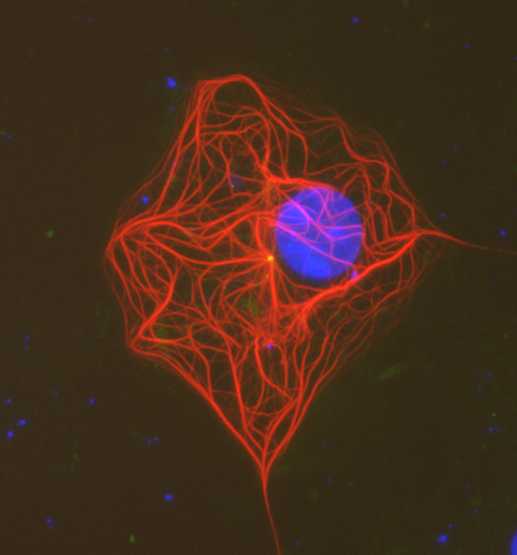**BIOL 447**

**Laboratory in Cell Biology**

**This is an in-depth lab course on the current and most utilized techniques in the study of cells. A weekly lecture covering the theory and/or practice of these techniques accompanies a weekly lab session that is limited to 12 students. The course topics change each year to keep current, but some of the topics covered in this course are:**

***Tissues***

Plant cell tissue culture, Handling explants, Organ regeneration from single cells, Preparing plant protoplasts, Producing transgenic plant tissue, Animal cell culture, Adherent cell manipulations, *in situ* gene expression, cell transformation

[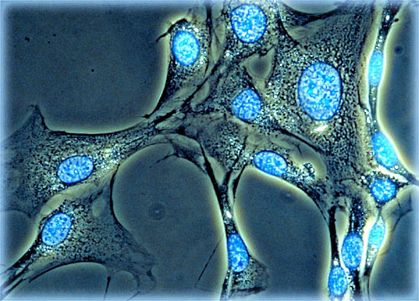](http://www.olympusmicro.com/galleries/fluorescence/pages/3t3dapismall.html)***Cells***

Electron microscopy, Tissue fixations and dehydrations, Tissue sectioning for light microscopies, Staining slides, Brightfield and fluorescence Microscopies, Determining membrane potential, Cell homogenizations

***Subcellular***

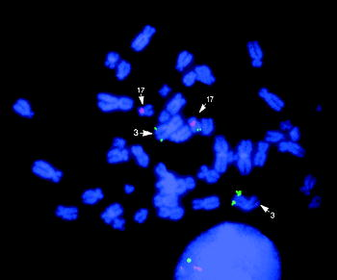 Isolation of organelles, Staining polytene chromosomes, Heterologous expression of reporters in frog oocytes, *In situ* hybridization, Super-Resolution light microscopy

***Molecules***

Protein determination, SDS PAGE, Immunoblot analysis, Tissue printing for enzymatic activity, Chromatographies, Use of prokaryotic and insect cells for heterologous expression of eukaryotic proteins for antigen production



**The intellectual content of this lab manual is UNC property. Do not copy or disseminate.**

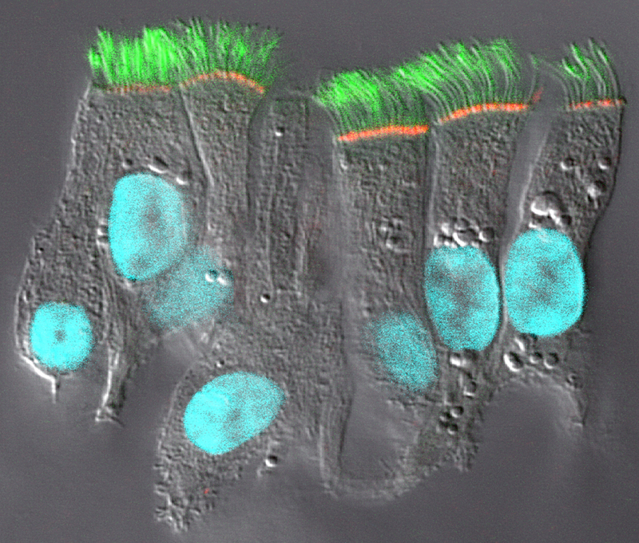

CFTR protein expression in well-differentiated human bronchial epithelial cultures. Well-differentiated cultures derived from human bronchial epithelial tissues were immunostained with CFTR and tubulin antibodies and analyzed on a Leica SP2 laser confocal microscope. The image represents an overlay of the DIC (grayscale), CFTR (red), cilia (tubulin, green), and nuclei (DAPI, blue) confocal planes, and depicts an epithelial cell sheet that contains a group of ciliated cells surrounding a goblet cell (bottle-shaped cell with no cilia). CFTR is expressed only at the apical membrane of ciliated cells, but not goblet cells. Magnification x190. Reproduced from Kreda et al 2005 Mol Biol Cell 16, 2154 with permission of ASCB / MBC

**Biol. 447**

**Laboratory in Cell Biology**

**Spring 2020**

Instructor: Dr. Alan Jones, ALAN_JONES@UNC.EDU

Dr. Paul Maddox pmaddox@email.unc.edu

Teaching Assistant: Alicia Tagliata [atagliat@ad.unc.edu](mailto:atagliat@ad.unc.edu)

**Lecture Tues. 9:05-9:55 AM, room GSB 1378___________**

Jan. 8 Introduction, Lab Biosafety Prof. Alan Jones

Required Reading:

Jan. 15 Tools I: Protein expression, antibody production SDS PAGE Prof. Alan Jones

Required Reading: Chapter 16 of Essential Cell Biology Alberts et al 3rd or 4th edition. This chapter is a summary of signaling pathways.

Jan. 22 Small G proteins in cancer Dr. Antje Schaefer

Required Reading:

Jan 29 The Cell Biology behind new Drug Delivery Yuan Gao

Feb. 5 Heterotrimeric G proteins: Beyond Biol 205 Part I

Feb. 12 Heterotrimeric G proteins: Beyond Biol 205 Part II:

Feb. 19 **Exam** - Jones

Feb 26 Introduction to light microscopy; Prof. Paul Maddox

Mar. 4 Sample preparation for Light microscopy; Prof. Paul Maddox

Mar. 11 **NO LECTURE or lab- SPRING BREAK**

Mar. 18 Digital Imaging; Prof. Paul Maddox

Mar. 25 Epigenetic regulation of centromeres; Prof. Paul Maddox

Apr. 1 Case Study: Cell Division; Prof. Paul Maddox

April 8 Biosensors and measuring forces in Cells; Prof. Paul Maddox

Apr. 15 **Exam --** Maddox

Apr. 22 no lecture

**Lab Exercise Thurs 1-5PM or sometimes later, room 130 Wilson Hall & exceptions**

Jan 9 No Lab

Jan. 16 Cell lysis optimization, protein quantitation

Jan. 23 Protein expression for antibody production

Jan 30 SDS-PAGE

Feb. 6 Animal cell culture, mammalian cell transfection

Feb. 13 Western blots and analyze last week’s results of cell transfections

.

Feb. 20 No Lab

Feb 27 Basic Light Microscopy; Transmitted and epi illumination

Mar 5 Mounting cells for live versus fixed imaging

Mar. 6th -16th **SPRING BREAK**

Mar. 19 Live cell imaging; animal model systems

Mar. 26 Confocal Imaging group 1 / Super-resolution (SIM) group 2 (Biology core)

Apr. 2 Confocal Imaging group 2 / Super-resolution (SIM) group 1 (Biology core)

Apr. 9 Photomanipulations; FRAP, FLIP, etc. (Biology Core, MDX lab)

Apr. 16 No Lab

Apr 23 No Lab

***Schedule subject to change***

**Grading**

1. 2 exams 50%

2. Performance 50%

a. Participation, Because of the structure of this class, unexcused absences or tardiness will drop your grade a letter for each instance.

b. Lab book

c. **curiosity, enthusiasm, teamwork , and attitude**

**No make-up exam- no exceptions**.

Final letter grade assignments are based the following

**A** - Mastery of course content at the highest level of attainment that can reasonably be expected of students at a given stage of development. The A grade states clearly that the student has shown such outstanding promise in the aspect of the discipline under study that he/she may be strongly encouraged to continue.

**B** - Strong performance demonstrating a high level of attainment for a student at a given stage of development. The B grade states that the student has shown solid promise in the aspect of the discipline under study.

**C** - A totally acceptable performance demonstrating an adequate level of attainment for a student at a given stage of development. The C grade states that, while not yet showing any unusual promise, the student may continue to study in the discipline with reasonable hope of intellectual development.

**D** - A marginal performance in the required exercises demonstrating a minimal passing level of attainment for a student at a given stage of development. The D grade states that the student has given no evidence of prospective growth in the discipline; an accumulation of D grades should be taken to mean that the student would be well advised not to continue in the academic field.

**F** - For whatever reasons, an unacceptable performance. The F grade indicates that the student's performance in the required exercises has revealed almost no understanding of the course content. A grade of F should warrant an adviser's questioning whether the student may suitably register for further study in the discipline before remedial work is undertaken.

**Exercise questions and things to do**

**I suggest that you read these beforehand so that you can ask questions like these in the lab when you have the chance. Otherwise, you’re on your own to get the answers! I am not requiring you to answers the following and *what I put forth below is far from comprehensive*. My advice if you want to get at least a C- in class then you should be able to answer intelligently questions like these.**

**********************************************

1. Why are tags added to recombinant proteins?
2. What kind of tags are used?
3. What kinds of expression systems are used and what are the advantages and disadvantages of each?
4. If a protein is not made as a soluble form in E. coli, what can be done to remedy this problem?
5. What is the lac promoter and how does IPTG activate heterologous gene expression?
6. What is a baculovirus and how is it used for heterologous expression of recombinant protein?
7. Read the review on ras at the end of this packet.

**********************************************

1. Describe the configuration of a sterile hood and the proper placement of hands and objects relative to the “clean” samples. Draw it.
2. Describe the structure of a gene and how recombinant forms of it can be used to measure gene expression. Include ways to visualize gene expression. How can the same method be modified to look at steady state levels of a protein?
3. What are the small G proteins and what do they do? How are they involved in cancer?
4. Describe how adherent animal cells are maintained in culture, including the passaging.
5. Describe the purpose and means for fixing tissues.
6. Explain some of the regulations that must be followed by certified animal care facilities.

**********************************************

1. Compare and contrast brightfield and transmission electron microscopy. Draw side-by-side the light/electron paths through the respective scopes.
2. Give examples of different types of fluorescent microscopy fluorophores and how they are used.
3. Compare and contrast fluorescent and scanning electron microscopy. Draw side-by-side the light/electron paths through the respective scopes.
4. Define numerical aperture and explain what this is and how the optics set the NA for imaging.
5. Describe in words and pictures how to properly adjust for Koehler illumination.

**********************************************

1. Why are SDS and ME used in SDS PAGE? What do they do? How is PAGE altered if one or both are not used?
2. Compare and contrast SDS PAGE with size exclusion chromatography.
3. Describe in detail how one performs 2-dimensional PAGE. What is the difference in resolution between 1- and 2-dimensional PAGE?
4. What is tandem mass spec? How does it work? How can it be used to sequence proteins?
5. How are monoclonal antibodies made? Include in your description, the use of selection drugs.