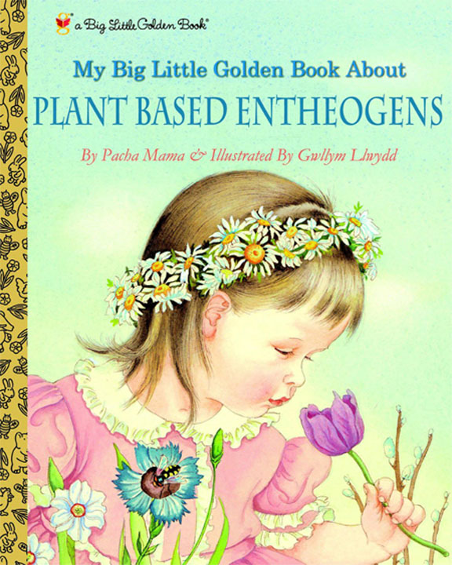

The Physician’s Garden
Fall 2018
Transfer Student Seminar Course taught in the fall semester as needed
Course limit is 20 students, must be a first year transfer student
Meets Tuesdays 2-3:15 (rm 1377 GSB) and Thursdays 2-4:45 (242 Wilson Hall) for ~4 instructor-student contact hr/wk Credits 3 hours

Prior to the first class, you must view James Burkes episode 12 of his series called Connections² https://www.youtube.com/watch?v=-Lmjl4yNAaM

You must read the entire book before August 21st: Wicked Plants by Amy Stewart
Must watch before August 21st introductory tutorial systematics and cladistics
https://www.youtube.com/watch?v=5Jlz-Uq35-A

Week 1
Tuesday, Aug 21st Introduction (overview, expectations, assignments), Brief introduction to Systematics. Scientific paper assignment. Discuss transportation for upcoming field trip. Sign up for GAEA club. Remember to bring dues for Thursday class.
Thursday, Aug 23rd Presentation by the Gardening and Ethnobotany in Academia club, GAEA. Collect dues. Treasurer Noel Martinez
Presentation by Elizabeth Gardner of Kava bar on botanicals. CONFIRMED but need title gardnerlawfirm@yahoo.com
Pass along last year’s project accomplishments to this year’s committees.
Discussion on scientific method. Beginning of your research project to find plant compounds that are antibiotic. Three Hypericum species will be discussed. Group your selves into 5 Research Teams of 4 today- At least one person in each group must be able and willing to stay until 6pm if needed. Note: BEFORE August 30th you need to be prepared to discuss the genus Hypericum and antibiotic sensitivity in class.
Today: Five drivers assigned for Sept 27th tour of Syngenta- list of cell numbers. List of visitors to Syngenta sent today. Choose a captain to lead the class to the NCBG on Thursday. Choose a host for cold youpon served on tour (get tea from Dr. Jones this day)
Week 2
Tuesday, Aug 28th How the Pacific Yew, the Periwinkle, and the Autumn Crocus Cured Cancer (Taxus brevifolia, Colchicum autumnale, Catharanthus roseus, colchicine, tubulin and microtubules) Read assigned science paper before Thursday class.

Thursday, Aug 30th UNC Herbarium, Plant Systematics. Learn to use a key to identify plants. (Dr. Alan Weakley and Carol Ann McCormick). Introduce 5 teams and get tentative assignments- can change to final assignment. TODAY: Choose among these Project Teams: Grounds I- sunny garden, Grounds II- shady garden, Public Affairs, Design I-Signage, Design II-Projects, Web Interface. See work outline below.
Also, the 5 Research Teams meet as ONE group. Identifying the plant you would like to test for antibiotic properties. Prepare your hypothesis and plan. Assign one team a positive control. Discuss your negative control. Prepare your hypotheses as a class.
Week 3
Tuesday, Sept 4th The Weed that Killed Lincoln’s Mother (Eupatorium rugosum, white snakeroot, The Milk Sickness, tremetol, citric acid cycle).
A Walk in the Woods of the Human Immune System (Toxicodendron [poison ivy], urushiol oils, human immune system and the allergic reaction).
Thursday, Sept 6th North Carolina Botanical Garden (Wendy Wenck) Class rides the city HU bus to NCBG (off @ McDonald house stop). Leaves Manning stop at UNC hospitals at 2:24). Return to campus on westbound HU at 4:15. It will be hot and buggy. Dress cool and bring bug repellant. Rain or shine. Meet Mike Dunn at Gazebo at 2:45. Dunn’s Cell # 919-612-8790
Week 4
Tuesday, Sept 11th Rare Botanical Book Collection Health Science Library and Medicinal Gardens across the World. (Dawne Lucas) The two Garden Ground teams need to recruit club help before Sept 20th – the work day
Research Hypothesis on Hypericum Antibiotic Activity and Plan due today- in writing- one per team of 4.
Thursday, Sept 13th Visit the Sam Hitt Medicinal Gardens, Garden work followed by McIver park source water protection park on campus lead by Ms. Geneva Greene.
https://gazette.unc.edu/2018/04/25/carolina-recognized-for-source-water-protection/
Reconvene to lab to read letters from 2018 class and prepare your semester goals. Committee Assignments, hand out exam 1
exam 1- take home
Week 5
Tuesday, Sept 18th Dr. Omar Rezk French Lilac: The Story of Metformin
Note that your faculty choices are due next week.
Thursday, Sept 20th Entire class to work in Gardens Teams, Some need to be prepare to get hot and dirty. Work on team goals for semester.
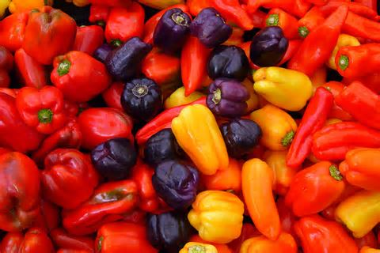
Week 6
Tuesday, Sept 25th Holy Hot Pepper! (Capsicum, the deadly nightshade family, Capsaicin, vanilloid receptor subtype 1, ion transport) for 2018—
Kayaks, Kramps, and Kures. Scientific curiosity leads to a company with a good product
TODAY: INDICATE YOUR FIRST AND SECOND CHOICES FOR RESEARCH FACULTY INTERVIEWS. MUST BE APPROVED (in class today). Failure to do so is marked as tardy.
How a Lowly Bacterium Helped Farmers Feed the World. Short presentation on Agrobacterium-mediated transformation.
Final arrangements (car assignments, directions) on transportation to Syngenta for Thursday.
Thursday, Sept 27th Visit state-of-the-art greenhouses at Syngenta RTP Closed shoes, long pants, hair tied up

MUST HAVE CONFIRMED TIMES FOR YOUR NCBG SERVICE DATES AND TIMES BY TODAY. COMPLETE THIS SERVICE BEFORE THANKSGIVING
Week 7
Tuesday, Oct 2nd Dr. Jacob Hill UNC School of Medicine, Naturopathic Medicine.

Thursday, Oct 4th Meet in class room then go together to Garden. Mini-presentations by each team to other teams on the exact semester goals for the semester. Presentation likely outside in the garden. Provide 5 hard copies (for other teams). Each team will walk the class through the garden to point out planned changes.
Part III: implementing goals
Week 8
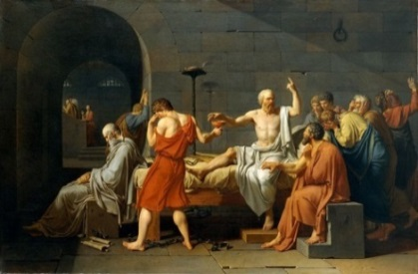
Tuesday, Oct 9th The Death of Socrates (Conium maculatum, Strychnos toxifera, hemlock alkaloids, curares, poison arrows, neuromascular synapse, nicotinic acetylcholine receptor).
The Death Angel (Amanita, amanitin, mRNA, RNA polymerase II, transcription)- short lecture.
If any remaining time, work in teams toward goals
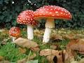
TODAY: turn in your plant material to be tested for antibiotics on this day. 25 mL of material in a 50-mL Falcon tube (provided). Label tube with names and information about material.
Thursday, Oct 11th Guest Mycologist, Dr. Henry van Cotton, cooking mushrooms - making Pleurotus bags, mushroom walk
Week 9
Tuesday, Oct 16th The Hound of Hades (The dog named Cerberus, Cerbera, Suicide Tree, Kerala India, Oleander, spies with poisons, cardiac glycosides, the heart, Na+/K+ pump)
Work in teams toward goals for remaining time
Pushkin’s Upas Tree and the Thirteen Concubines (Antiaris toxicara, The Upas tree, cardiac glycosides in art and lore)
Thursday, Oct 18th Fall Break 2016
Week 10
Tuesday, Oct 23rd exam 2
Thursday, Oct 25th UNC School of Pharmacy- Medicinal Chemistry Research, Guest: Dr. Kenneth Pearce Closed shoes, long pants, hair tied up, lab coats, and eye protection required.
SERVICE WORK FOR HERBARIUM MUST BE COMPLETED NOW
Week 11
Tuesday, Oct 30th Homer’s Cyclops (California corn lily, Veratrum californicum, the teratogen cyclopamine and the hedgehog signaling pathway)
Thursday, Nov 1st Testing the antibiotic effect of plant extracts: Part 1- controls and preparation of plant material. Learning to use a pipette and measure growth by OD.
Week 12
Tuesday, Nov 6th Opiates and μ (Papaver somniferum, poppy, opium, morphine, mu 2 receptors, G-protein coupled signaling)

Beautiful Lady, What Big Eyes You Have (Atropa belladonna, deadly nightshade, muscarinic acetylcholine receptor, G protein coupled signaling in muscle cells)

Thursday, Nov 8th Testing the antibiotic effect of plant extracts: Part II.
Week 13
Tuesday, Nov 13th Dr. Leslie Hicks (UNC Chemistry) Natural product bioactive peptide discovery via PepSAVI-MS
Thursday, Nov 15th Election platform presentations. GAEA Club president Taylor Collier. Final work on the UNC Medicinal Gardens- Complete all tasks, prepare for presentations. New plant signs must be installed today and checked by Dr. Jones for any needed changes.
Week 14
SERVICE WORK FOR NCBG MUST BE COMPLETED BEFORE Nov 21st
FACULTY ASSIGNMENT DUE Nov 21st
Tuesday, Nov 20th Professor Bryan Roth (UNC Pharmacology) Salvia divinorum: from plant to human

Thursday Nov 22nd Thanksgiving Day -- No Class --
Week 15
Tuesday Nov 27th Discuss the assigned etoposide paper in class.
Thursday Nov 29th 20-minute Presentations of Garden work by each committee. Design a GAEA club T-shirt.
Class Photo. Turn in: Team letters to 2018 Class, team presentation, and all other tangible items to be filed. Files as pdfs must be labeled as per instructions. Send presentation and letter as a pdf to Dr. Jones.
SERVICE WORK FOR GAEA CLUB MUST BE COMPLETED BEFORE Nov 31st
Week 16
Tuesday Dec 4th Exam 3

Assignments:
Coffee with Faculty- You buy. - You are assigned to write ~1-page article on a UNC life science researcher. Faculty member working on problems in the life sciences are found in the Dept of Biology, Department of Psychology, and throughout the Schools of Medicine and Pharmacy. This must be a tenure-track research faculty of any rank. Instructors, aka teaching faculty, cannot be used for this assignment. You may not pick a professor you know already- e.g. teaches a course you are taking or took. You must have a first and second choice approved by Dr. Jones in class on Sept 25th. Your article will contain a photo of you and your interviewee with your coffees plus illustrated with one or more figures on the science you discuss. DUE BEFORE Thanksgiving Day.
Any life science research faculty except the following:
(2015) A Maddox, R Duronio, S Frye, A Matthysee, R Peet, P White
(2016) A Jones, S. Crews, C, Shiau, P Gensel, J. Dangl, S Grant, Hopfinger, S Sekelsky, C Michel, J Dowen, Jaspers
(2017) C. Mitchel, M Evans, D. McKay, A Maddox (Shaub), Riveros (Geology), Vicky LeGrys, H. Kelly, Zach Nimchuk, Wikberg, J Bruno, K Bloom, C. Willet, J. Bruno, Wikberg (clinical tech), Ashkin, B. Stahl

2018 Garden Teams-

Pick a team by Aug 30th FIRST COME – FIRST SERVED but can change to final by September 14th - IF YOU CAN NEGOCIATE WITH SOMEONE TO CHANGE- BUT then no changes allowed AFTER Sept 14th.

Sunny Garden Grounds Team (4)

- Mulch using 4 yards of compost
- Weed to perfection
- Install Campotheca tree in collaboration with Geneva Green
- Install Hypericum (2 species)
- Install Digitalis
- Install Atropa
- Install Valerium
- Install Galega
- Water the garden for 4 weeks
- Make at least one improvement- preapproved by Jones
- Research on additional plants for 2019 class to install to include in your letter to them
- Recruit other Club members to enable them to log their hours
- Report tasks, times and names to GAEA Club President to log hours

Shady Garden Grounds Team (4)

- Mulch using 4 yards of compost
- Weed North Garden to perfection
- Trim trees
- Dig out all Christmas fern in south garden
- Thin out Ginger in south garden
- Thin out other species
- Repair white rock accent on walk-way in North Garden
- Make at least one improvement- preapproved by Jones
- Install ivy
- Install Digitalis
- Install Atropa
- Install Valerium
- Water the garden for 4 weeks
- Research on additional plants for 2019 class to install to include in your letter to them
- Recruit other Club members to enable them to log their hours
- Report tasks, times and names to GAEA Club President to log hours

Design Team- Signage (4)
- Determine if some plants need signs removed- remove them
- Check for accuracy – all signs- see note from visitor below
- Change all signs to emphasize chemical with structure NEEDS APPROVAL BY JONES BEFORE THANKSGIVING
- Add signs to latest installations that are lacking them
- Make list of signage changes for 2019 class
Design Team- Projects (3)
- Work with artists to finish the art wall by May 2019
- Make inventory of projects and priority for 2019 class
- Preliminary organization of unveiling next year- possible interaction with the press and high level UNC such as Chancellor Folt.
Web Technology Team (3)
- Make-over (i.e. New) of web page interface for cell phone
- Confirm each sign has a page and that the QR code is working from cell phone
- Make a consistent format with each page that looks good on a cell phone
- Find a way to un-bury the Garden web page from HSL website
- Determine key bottleneck issues for 2019 class
Public Affairs (2)
- Get financial commitments form Chapel Hill/Carrboro Garden Clubs to finish bench acquisition project ~$3000
- Get written permission from Jill Coleman (UNC) for bench placement
- Brochure makeover
- Determine key bottleneck issues for 2019 class
***********************************************************************************************
Design Team I- READ THIS note from visitor- example of what you need to address
Hi,

I am writing you out of the blue to comment on the garden (Sam Hitt memorial garden by the HSL). Firstly, it's a wonderful project and thank you for helping maintain it with the students of BIO217! I think that the concept for the class is a great idea and it's awesome you've chosen to teach it!

However, the reason I am writing you is to ask if you know who I should contact to fix one of the signs for the plants in the garden?

Specifically, yarrow (Achillea millefolium) is mislabeled in the garden by it's varietal name chosen for planting ("Saucy seduction", the red varietal vs the normal white). On the webpage linked by the QR code (http://medicinalgardens.web.unc.edu/saucy-seduction/), the common white varietal of yarrow is shown but not mentioned that the plant is yarrow. It provides an alternative name as "shining clubmoss" (Huperzia lucidula), which is incorrect and is likely at a different location in the garden. I noticed that this morning and thought it would be nice to correct so that people can better learn the fantastic plants that are available to learn about on campus.

Thanks!

Best regards,
Matt

Matt Geden, PhD
Mohanish Deshmukh Lab
University of North Carolina-CH

Assignments:
- Presentations. 20-min+ Presentation, Letter to 2019 Class, other tangible items such as a brochure or letter of solicitation DUE Nov 29th. NOTE THAT ALL ITEMS MUST BE IN A WORDDOC OR PDF FORMAT (EVEN YOUR PRESENTATION- note that companies like Prezi charge $$ for pdf files- don’t use them).
- Service hours. You are required to spend 1 ½ h service to the UNC herbarium, 1 ½ h service to GAEA club (to be completed before Thanksgiving- hours working outside on the garden for class count), and 1 ½ h service to the NCBG. Sign-up for the UNC herbarium is located here:
https://docs.google.com/document/d/1W60zOdS6xKG59ZSoJV7XxOdV7isk9lZPZqZqeIAT93s/edit
The sign up sheet for the NCBG is located here: _________________
GET FROM WENDY
Given enough notice, students may reschedule when an unexpected conflict arises. “no-shows” are given a zero grade- there is no need to reschedule.
- Immediate Club membership. You are required to be a member in good standing with the Gardening And Ethnobotany in Academia Club (GAEA) for one year. Show proof of membership, paid dues, and 1 ½ h service/year, meeting attendance. Noel Martinez is the club treasurer and will handle the dues.
- Lab report of your experiments. See template at end. Due Nov 15th.
Absence and tardy penalty:
You may not miss a class without prior excuse. If you are late or miss a class, a full grade will be taken off your final grade for each instance.

Reading:
No course pack. Wicked Plants by Amy Stewart- to be purchased on line- not the book store. You must own a copy of Newcomb’s Wildflower Guide. Buy it. You will read a scientific paper for discussion to be determined and maybe a book chapter needed for the last lecture. The lectures and the scientific paper are located at your Sakai page.
Grading:
Grading: Exams 1 through 3 will account for 50% of the total final grade, the remaining 50% are for enthusiastic participation, the coffee meeting with faculty report, service, final presentation, etc. The grading is not curved. Missing or late assignments will be given a score of zero.
Final letter grade assignments are based the following
A - Mastery of course content at the highest level of attainment that can reasonably be expected of students at a given stage of development. The A grade states clearly that the student has shown such outstanding promise in the aspect of the discipline under study that he/she may be strongly encouraged to continue.

B - Strong performance demonstrating a high level of attainment for a student at a given stage of development. The B grade states that the student has shown solid promise in the aspect of the discipline under study.

C - A totally acceptable performance demonstrating an adequate level of attainment for a student at a given stage of development. The C grade states that, while not yet showing any unusual promise, the student may continue to study in the discipline with reasonable hope of intellectual development.

D - A marginal performance in the required exercises demonstrating a minimal passing level of attainment for a student at a given stage of development. The D grade states that the student has given no evidence of prospective growth in the discipline; an accumulation of D grades should be taken to mean that the student would be well advised not to continue in the academic field.

F - For whatever reasons, an unacceptable performance. The F grade indicates that the student's performance in the required exercises has revealed almost no understanding of the course content. A grade of F should warrant an adviser's questioning whether the student may suitably register for further study in the discipline before remedial work is undertaken.

Outline for Lab Reports
An outline is a plan or blueprint for your report. It helps you structure your report by using roman numerals, letters and numbers to organize each section of the report. Use the outline below as a template to guide you by writing your information in each section. You need not limit yourself to this outline, therefore, you can use more letters and numbers if warranted. This outline will later be used to help you put together your lab report as you add more information to it. The final lab report will not include the roman numerals, letters and numbers but instead you will write each section in paragraph form.
Title and date (centered on first page)
The title should reflect the independent and dependent variable. For example, “The effects of Hypericum extract on the growth of Staph. epidermydis”. It should be brief and descriptive.
- Introduction
- Include (here) a few sentences of preliminary observations or background information (what is already known) about the subject
- Answer here: Why is the lab experiment being done (What do you hope to learn)?
- Hypothesis
- Include here a possible answer to why you are doing the lab (If we do this…. then we think this should happen)
- Identify independent and dependent variables here
- Materials and Methods
- For this section of the outline briefly state in step-by-step fashion what and how you did the experiment. Write down how lab was conducted with materials as part of the procedure.
- Include controls used here
- Results
- Here summarize data collected by describing a condensed version of the data
- Use tables, graphs, and charts with appropriate units, labeled axis and legends
- Discussion
- First, state whether you accept or reject your hypothesis based on your results.
- Then include interpretations and opinions of your data and observations
- Why did the results turn out the way they did?
- How does your control affect the results?
- Discuss any sources of error. Include any unusual circumstances, problems or difficulties that were encountered and ways they could be improved.
- In this section you should discuss how the information gathered during the project is useful to society or the individual and what you have learned.
References
Properly cite all sources used. Minimum of two major sources one of which includes the lab manual.

