Syllabus for Biology 891 Course Spring 2019

Credits: 2
Meeting time: Friday 11:35-1:20pm in Coker 215, with Lunch Bunch from 12:20-1:20
Faculty Mentor: Christopher S. Willett, Biology, 2252 GSB, willett4@email.unc.edu

Course Goals and Key Learning Objectives:

- Facilitate the acquisition of intellectual depth and highlight interconnections between the fields of ecology, evolution, and organismal biology (EEOB)
- Develop critical thinking skills, in relation to the interpretation and critique of the primary scientific literature
- Gain an increased understanding of the scientific process by listening to seminars from graduate students and other researchers at the weekly biology lunch bunch seminar
- To increase interactions and facilitate collegiality and collaboration between graduate student cohorts
- To develop presentation skills and ability to present research ideas

Target audience: 1st and 2nd year Biology EEOB graduate students and other graduate students interested in this subject area.

Course Prerequisites: none

Course Requirements: This course is aligned with the weekly Lunch Bunch seminar that is held in Coker 215 on Fridays at 12:20 and students are required to attend this seminar as part of course participation. This seminar is given most weeks by a Biology Department graduate student, postdoc, or faculty member (or visiting scientist) on a subject related to research in ecology, evolution, or organismal biology. Students are encouraged to contribute to the discussions during and after these seminars.

A key goal for all EEOB scientists is to expand their knowledge beyond their specific study area, and to be informed about general areas of significance across ecology, evolution, behavior, and organismal biology. The hope is that interactions with different primary literatures (as well as among students) will highlight the connections and similarities between different fields. We will work toward this goal in multiple ways: through attendance of the weekly seminar, by reading and discussing the primary scientific literature, and by having students present several short talks on their own research and receiving peer feedback.

Paper discussion: Most weeks will be journal club-style discussions of a paper broadly related to the research field of the Lunch Bunch seminar. Each week, one or two students will select and co-lead discussion of a paper (the format for discussion to be determined by the group). In order to encourage discussion, no PowerPoint (or related media) permitted (chalkboard okay).

Paper selection: For each week's paper, keywords related to the Lunch Bunch seminar will be provided. Papers should be selected in relation to these but do not have to encompass all keywords. Papers should represent important/innovative/highly cited contributions to the field being discussed, and should be a level that will be accessible to all students in the class (even if outside of their areas of expertise). Note that for some week’s papers non-scientific papers or other discussion formats may fit topics better. Students should discuss their potential paper choices/discussion ideas with the instructor before finalizing. Please post the paper on Sakai no later than Tuesday night of the week it will be discussed so everyone has time to read it.

Weekly preparation: Students not leading discussion are still expected to read the paper each week prior to class and are also responsible for formulating 2-3 relevant written questions or discussion points related to the paper (to be posted on Sakai in the weekly forum). These can potentially be used for the paper discussion that day.

Class presentations: For two weeks mid-semester, we will have the enrolled students present short talks or presentations about a topic related to their research projects. The class will decide on one format and all students will present using this format on one of the two weeks. Example formats include: elevator speech (how you would explain your research if someone asks on an elevator), chalk talks, or presentation of preliminary work or future research idea. These talks will allow students to hear about their peers' projects, provide practice in presenting work to a non-specialist group of peers, and allow the students to get peer feedback.

Schedule:
Date: Lunch Bunch Speaker: Keywords:

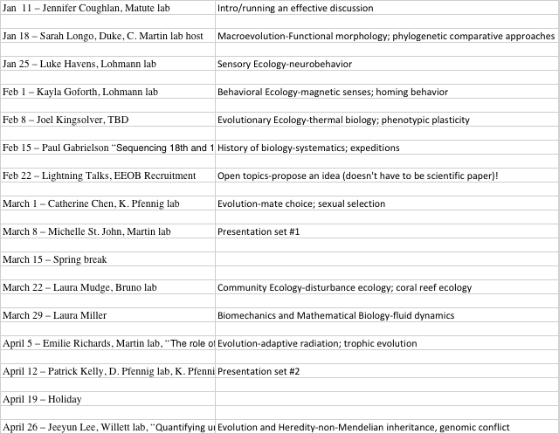

Grading and class policies: An acceptable grade (pass) in the course can be achieved by attending class and the Lunch Bunch seminar each week, leading at least one topic during the semester, reading the papers each week, participating in discussion, and giving an in-class presentation. Attendance will be taken each week and students cannot miss more than two classes (unexcused absences). Please notify the professor if you will have an excused absence for a class prior to absence if possible as make-ups may be possible in some circumstances. High pass grades will be awarded only for exceptional circumstances when students go beyond the basic requirements for the course, participate fully in the discussions in class and at Lunch Bunch, and have an outstanding project.

Note on possible changes to syllabus: This syllabus is subject to change including changes in the schedule or specific class requirements. Any changes will be presented clearly by the professor and discussed among the class members if the changes are of significant importance.

Diversity statement: The Department of Biology values the perspectives of individuals from all backgrounds reflecting the diversity of our students. We broadly define diversity to include race, gender identity, national origin, ethnicity, religion, social class, age, sexual orientation, political background, and physical and learning ability. We strive to make this classroom and this department an inclusive space for all students.

Important resources on campus

Counseling and Psychological Services: CAPS is strongly committed to addressing the mental health needs of a diverse student body through timely access to consultation and connection to clinically appropriate services, whether for short or long-term needs. Go to their website: https://caps.unc.edu or visit their facilities on the third floor of the Campus Health Services building for a walk-in evaluation to learn more.

