LOCAL FLORA (BIOL 272)

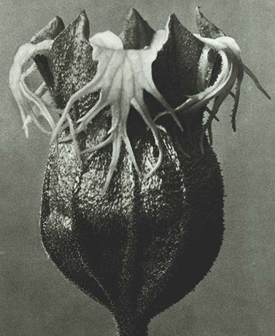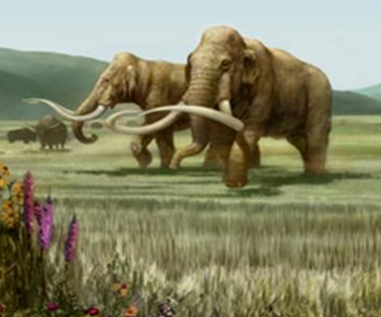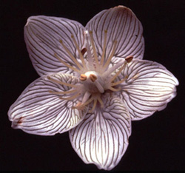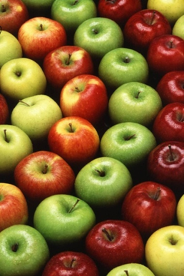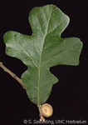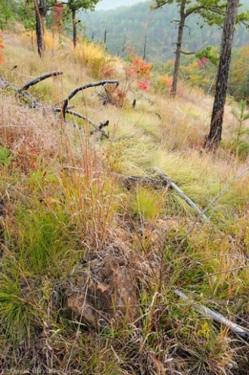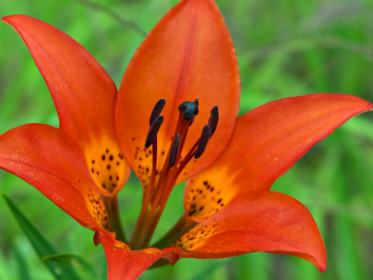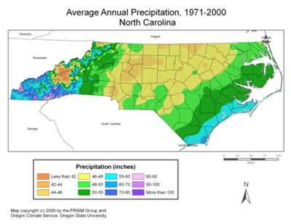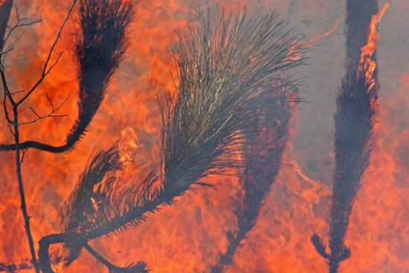

Instructors:
Alan Weakley (email: weakley@unc.edu)
Derick Poindexter (email: dbpoindexter@gmail.com)
Teaching Assistants:
Jo Spooner (email: acalliope@gmail.com)
Eric Ungberg (email: ungberg@gmail.com)
Brandon Fuller (email: jbfull@live.unc.edu)
Credit Hours: 4
Office hours: By appointment.

Version
2020 Fall.

Course Schedule
Lecture: MWF: 10:40-11:30 (via Zoom; also recorded and posted for asynchronous viewing)
Lab: some synchronous meetings at scheduled times below (see schedule and Sakai posts going forward), and also asynchronous assignments
Section 401: M 2:40-5:40
Section 402: T 1:15-4:15
Section 403: W 2:40-5:40
Section 404: Th 1:15-4:15
And via assignment (asynchronous)
Exam: Monday, November 23rd, 8 a.m.
Detailed schedule posted as spreadsheet

Course Purposes
- Understand the diversity and evolution of plants
- Recognize native (and some alien) plants of North Carolina (especially the Piedmont), understand their ecology, economic importance, and conservation challenges
- Look at plants – learn to see and describe their details; learn plant structures needed to identify plants, and some specialized terminology that describes those structures
- Identify plants using books and online tools (a skill to last a lifetime); use “keys” and other identification tools to aid in the identification of plants
- Make “citizen science” observations of wild plants, identifying plants, confirming the identifications of others, and adding to data on the North Carolina and southeastern US flora
- Learn about the biogeography, forest types, and plant diversity of North Carolina and the southeastern United States
- Appreciate conservation needs of the North Carolina flora
- Plants we eat and wear – what are they and where do they come from?

Course Textbooks and Apps
Judd et al. (2016) Plant Systematics: A Phylogenetic Approach (4th Edition)
Weakley, Ludwig, & Townsend (2013) Flora of Virginia or (2017) Flora of Virginia app ($19.99, available in iOS or Android)
iNaturalist app (available free in iOS or Android)
Optional: Weakley (2020) Flora of Southeastern North America – pdf version will be available for download
Optional: Weakley & Lee (2017) FloraQuest (an iOS app) – available in the Apple Store

Assignments and Grading
Lecture exams (45%): These are a mixture of short answer, long answer, multiple choice, matching.
Midterm 20%
Final 25% (cumulative, sort of)
Lab quizzes (30%):
4 quizzes on recognition and identification of 100-110 plant species (5%, 5%, 5%, 7%)
1 FloraQuest (“scavenger hunt”), working in teams to find examples of 75 plant features! (8%)
Citizen Science (iNat) Project (20%): Make observations of native and naturalized plants in iNaturalist and identify and comment on others’ observations. Write a short reflection on the experience.
“Plants you ate and drank in a day” log (5%)

Course policies
Office hours and availability
The TA(s) are the first option for meeting about any issues, but I am also available. I am usually available immediately following class to talk with you or to schedule appointments. For longer meetings, it’s usually best for us to schedule an appointment. Email is the best way to contact me to schedule appointments, ask questions, let me know about an absence, etc. I check email regularly during weekdays and early evenings, and I can usually respond to you within a few hours (often sooner). While I cannot guarantee a reply late at night or over the weekend, I am usually able to respond within 24 hours. If I know I will be unavailable by email on a particular weekend, I will notify the class in advance.

Participation and attendance
Virtual attendance at lectures is strongly encouraged, but not mandatory; note, however, that non-attendance is strongly correlated with lower grades. Attendance and general involvement with the class is also used as a basis for any tweaking of your final grade.

Late work
This applies realistically only to the Project. 20% deduction per day.

Plagiarism
Carefully review UNC policies on plagiarism. This will mainly pertain to your individual project. We will carefully scrutinize these papers for signs of plagiarism, and will report plagiarism if found.

THIS SYLLABUS MAY BE CHANGED DURING THE COURSE OF THE CLASS DEPENDING ON DEVELOPMENTS WITH TEACHING THIS REMOTELY

