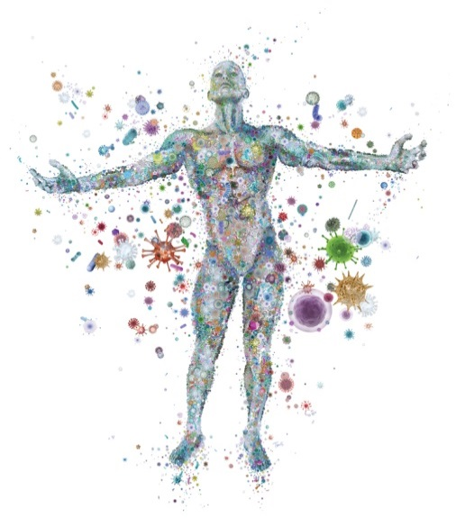
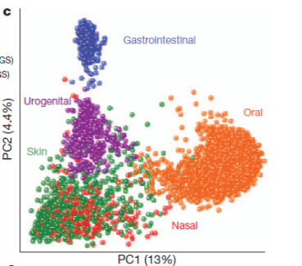
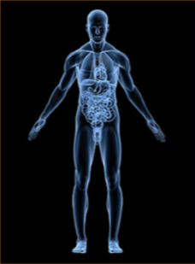
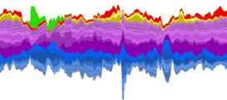
BIOL 842: The Human Microbiome in Health and Disease
(Seminar in Cell Biology and Biochemistry)

Instructor:
Dr. Elizabeth Shank
eshank@unc.edu
Genome Sciences Building 4157
919-962-4459
Office hours by request.

Course description:
By now most of us have heard about how human-associated microbial communities (or microbiomes) impact our health, and how disruptions in these communities can lead to disease (from diabetes and obesity to periodontal disease and gastrointestinal imbalances). But what are the details of the research studies that have led to these compelling connections, and what are the limits of the existing data? In BIOL 842: The Human Microbiome in Health and Disease, we will read and critically evaluate primary literature to gain a deeper understanding of the current state of knowledge about microbe-human interactions. We will explore both seminal papers (which initially revealed the pivotal role of host-microbe interactions), as well as current and cutting-edge literature to learn about what is known about the human microbiome and its role in human health and disease.

Target Audience:
This course is intended for graduate students and should satisfy most degree programs requirements for a primary-literature-based class. If you have any questions about your readiness to participate in this course, please email me.

Time and place:
The class will meet weekly on Thursday from 9:15 am – 11:00 am in 4101 Genome Science Building.

Organization:
The first few weeks will provide an overview of the field and allow us to briefly discuss the topics and papers to be covered. Each subsequent week, we will read scientific articles in advance of class (typically one primary literature paper and a review article), and selected students will lead a discussion (not by lecturing, but by facilitating a group discussion) in which we will critique the paper(s), interpret the data, and discuss the implications of the results. Each registered student is required to lead at least one weekly discussion, and the responsibility of leading weekly discussions will be distributed as equally as practical among all students.

Course Goals:
The goal of this course is to teach students to read papers critically, put results into context, and learn about the historical and current state of human microbiome research.

Expectations:
Each student is required to attend weekly class meetings, read assigned material, and organize and facilitate at least one discussion session. Students are expected to be courteous and respectful to the other participants and their ideas, and honor the Honor Code.

Grading:
Participation (50%):
Speaking up in class discussions
Contributing personal insights and ideas during class
Being actively involved in selecting papers and topics
Student presentations (50%):
Explanation of the context, experimental approaches, and results of the paper
Clarity of presentation
Effort to engage other students in discussion

Potential topics/papers:
Specific topics within the human microbiome field to be covered will be selected by consensus with guidance from the instructor. These topics include papers discussing: the initial discovery of the microbiome; how we study the microbiome; microbiome distributions in healthy individuals; composition of specific body sites’ microbiome (nose, skin, teeth, urogenital, etc.); microbiome’s role in diseases such as IBD, colitis, obesity, diabetes; effects of diet on microbiome; interactions with the immune system and resistance to pathogens; fecal transplants; how the microbiome changes from birth to death or over the course of days and years; how our microbiomes have changed over evolutionary time; how pregnancy affects the microbiome; how antibiotics affect the microbiome; interactions of the microbiome with our brain; the fungal and viral microbiomes; and how ecological theory advances our understanding of the microbiome.

Please Note:
The professor reserves to right to make changes to the syllabus, including the specific topics and papers that will be covered, or project due dates when unforeseen circumstances occur. These changes will be announced as early as possible so that students can adjust their schedules as needed.

HONOR CODE:
All work done in this class must be carried out within the letter and spirit of the UNC Honor Code.

