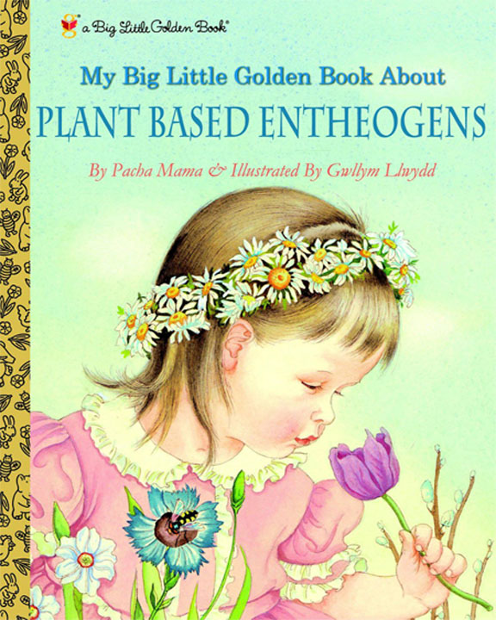

The Physician’s Garden
Fall 2019
Transfer Student Seminar Course taught in the fall semester
Course limit is 20 students, must be a first year transfer student
Meets Tuesdays 2-3:15 (rm 1377 GSB) and Thursdays 2-4:45 (242 Wilson Hall) for ~4 instructor-student contact hr/wk Credits 3 hours

Prior to the first class, you must view James Burkes episode 12 of his series called Connections² https://www.youtube.com/watch?v=-Lmjl4yNAaM
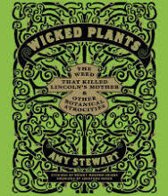
You must read the entire book before August 21st: Wicked Plants by Amy Stewart

Read this article before class: https://www.chathamnewsrecord.com/stories/the-next-frontier-for-hemp,2163
Must watch before August 21st introductory tutorial systematics and cladistics
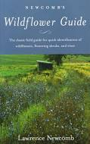
https://www.youtube.com/watch?v=5Jlz-Uq35-A
You need to buy Newcomb’s Wildflower Guide (used is fine)
Week 1
Tuesday, Aug 20th Introduction (overview, expectations, assignments), Brief introduction to Systematics. Scientific paper assignment. Discuss transportation for upcoming field trip. Sign up for GAEA club. Remember to bring dues for Thursday class.
Thursday, Aug 22ND Presentation by the Gardening and Ethnobotany in Academia club, GAEA. Collect dues by club treasurer.
Presentation by Elizabeth Gardner, Esq of a Kava Bar (Krave, Carrboro) and Sgt Deshaises, The Birth of Ethnobotanical Subculture in America: Contemporary Uses of Kava Kava, Kratom, and Hemp-derived CBD—at odds with Big Pharma. Law Enforcement Issues with Legalized Herbals.
Pass along last year’s project accomplishments to this year’s committees.
Today: Five drivers assigned for Oct 3rd tour of Triangle Hemp and Oct 24th to Isolera, Inc - list of cell numbers. List of visitors to Triangle Hemp sent today. Choose a captain to lead the class to the NCBG on Thursday. Choose 2 hosts for cold youpon served on tour (get tea from Dr. Jones this day)
Note that your faculty choices are due next week.
Week 2
Tuesday, Aug 27th How the Pacific Yew, the Periwinkle, and the Autumn Crocus Cured Cancer (Taxus brevifolia, Colchicum autumnale, Catharanthus roseus, colchicine, tubulin and microtubules) Read assigned science paper before Thursday class (even though we are not discussing this paper until November).

Thursday, Aug 29th UNC Herbarium, Plant Systematics. Learn to use a key to identify plants. (Dr. Alan Weakley and Carol Ann McCormick). Introduction to teams and get tentative assignments. Note: each team (see 3 below) will collect in the wild plant samples for drying and testing for antibiotic activity later this semester. EACH member of the team must identify and collect two samples (bags provided). Dried samples due Oct 8th.
In addition, TODAY:
- Everybody must join either: Grounds I team- sunny garden OR Grounds II team- shady garden
- Also, pick one of these teams: (See the selection at end of this syllabus) Public Affairs, Design -Signage, Web Interface. See work outline toward end of this syllabus. It is best that everyone in the Web and Pub affairs teams be in either Grounds I or Grounds II.
- Also, assemble into 4 research teams of 4-5 people. At least one person in each group must be able and willing to stay until 6pm if needed. These 4 research teams meet separately to identify the plants you would like to test for antibiotic properties. Prepare your hypothesis and experimental plan. Discuss positive and negative controls. Prepare your hypotheses as a team.
- Also, start thinking about your T shirt design to be ordered Nov 12th
- DUE TODAY: INDICATE YOUR FIRST AND SECOND CHOICES FOR RESEARCH FACULTY INTERVIEWS. MUST BE APPROVED (in class today). Failure to do so is marked as tardy.
Week 3
Tuesday, Sept 3rd The Weed that Killed Lincoln’s Mother (Eupatorium rugosum, white snakeroot, The Milk Sickness, tremetol, citric acid cycle).
A Walk in the Woods of the Human Immune System (Toxicodendron [poison ivy], urushiol oils, human immune system and the allergic reaction).
Thursday, Sept 5th North Carolina Botanical Garden (Wendy Wenck) Class rides the city HU bus to NCBG (off @ McDonald house stop). Leaves Manning stop at UNC hospitals at 2:24). Return to campus on westbound HU at 4:15. It will be hot and buggy. Dress cool and bring bug repellant. Rain or shine. Meet Mike Dunn at Gazebo at 2:45. Dunn’s Cell # 919-612-8790
Week 4
Tuesday, Sept 10th Rare Botanical Book Collection Health Science Library and Medicinal Gardens across the World. (Dawne Lucas). Come to GSB 1377 and we will walk over to the Special Collections Learning Center in Wilson Library. We will wait in the Wilson Library lobby.
Thursday, Sept 12th Visit the Sam Hitt Medicinal Gardens, Take notes during this tour for your action items toward your team goals
Reconvene to lab to read letters from 2018 class and prepare your semester goals. Committee Assignments, hand out exam 1. Letters are in dropbox.
Discussion: 1) Research Hypothesis on Plant extract Antibiotic Activity and Plan in writing- one per team. 2) Final sign design- Design Team only
exam 1- take home
Sept 13th. Last chance to switch teams.

Week 5
Tuesday, Sept 17th Opiates and μ (Papaver somniferum, poppy, opium, morphine, mu 2 receptors, G-protein coupled signaling)

Beautiful Lady, What Big Eyes You Have (Atropa belladonna, deadly nightshade, muscarinic acetylcholine receptor, G protein coupled signaling in muscle cells)

Thursday, Sept 19th Grounds Team II (Shady garden). Weeding, mulching, install Valerian root, Colchicum, Foxglove and other plants Everyone else work on team goals for semester. Also work on first draft of your signs. Be ready to show Dr. Jones for first check.
.
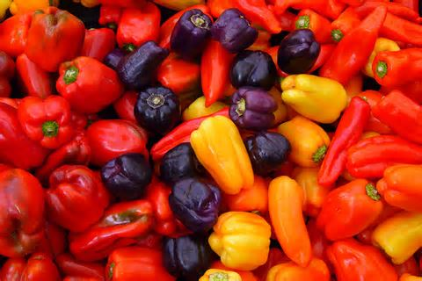
Week 6
Tuesday, Sept 24th Holy Hot Pepper! (Capsicum, the deadly nightshade family, Capsaicin, vanilloid receptor subtype 1, ion transport)
Kayaks, Kramps, and Kures. Scientific curiosity leads to a company with a good product
DUE TODAY: You must have completed your faculty interview OR have a confirmed near future date to meet.
How a Lowly Bacterium Helped Farmers Feed the World. Short presentation on Agrobacterium-mediated transformation.
Final arrangements (car assignments, directions) on transportation to Triangle Hemp for next Thursday Oct 3rd.
Thursday, Sept 26th Grounds Team I (Sunny garden). Weeding, mulching, install deadly nightshade, foxglove, willow, poppy and other plants. Everyone else work on team goals for semester.

BY TODAY MUST HAVE CONFIRMED TIMES FOR YOUR NCBG SERVICE DATES AND TIMES. Note: MOST OR ALL OF YOU WILL COMPLETE THIS BY SERVING THE PLANT SALE OCT 27TH OR 28TH BUT IF YOU CANNOT ON THAT WEEKEND, YOU MUST COMPLETE THIS SERVICE BEFORE THANKSGIVING
Week 7
Tuesday, Oct 1st Convoluted Cannabis (Hemp lecture) Guest Speaker, Dr. Angela Post, NCSU Soil and Crop Science Department

Thursday, Oct 3rd Visit Triangle Hemp in Durham. Closed shoes are required. Drivers will be ready waiting behind Wilson Hall at 2PM. The rest of class will meet in class then go down and load into cars at 2:02PM. If you are late, you will miss your ride and be marked absent.
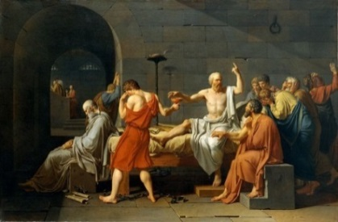
Week 8
Tuesday, Oct 8th The Death of Socrates (Conium maculatum, Strychnos toxifera, hemlock alkaloids, curares, poison arrows, neuromascular synapse, nicotinic acetylcholine receptor).
The Death Angel (Amanita, amanitin, mRNA,
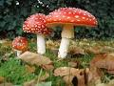
DUE TODAY: turn in your plant material to be tested for antibiotics on this day. Sample bags provided. Label with names and information about material.
Thursday, Oct 10th Guest Mycologist, Dr. Henry van Cotter, cooking mushrooms - demo Reishi and Pleurotus cultures that you can do at home, mushroom hunt on campus, rain or shine- dress appropriately – note: in fall 2018, we went out during a hurricane (and had a blast!)
Week 9
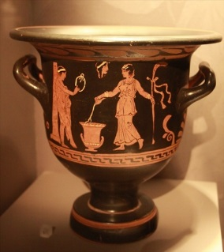
Tuesday, Oct 15th Wine, Olive Oil, and Politics at Azoria, an Ancient city-state on Crete Professor Margie Scarry, Dept Anthropology UNC
Work in teams toward goals for any remaining time
Take-home exam 2
Thursday, Oct 17th Fall Break 2016
Week 10
Tuesday, Oct 22nd New insights into psychoactive drug actions Professor Bryan Roth Dept of Pharmacology UNC

Final arrangements (car assignments, directions) on transportation to Isolera, Inc for next Thursday Oct 24th.
Thursday, Oct 24th Visit Isolera in Oxford NC to observe CBD extraction. Closed shoes are required. Drivers will be ready waiting behind Wilson Hall at 2PM. The rest of class will meet in class then go down and load into cars at 2:02 PM. If you are late, you will miss your ride and marked absent. Ryanne Allocca, Isolera Extracts, 984-514-9765
SERVICE WORK FOR HERBARIUM MUST BE COMPLETED NOW
Most or all of you will work at the NCBG Plant Sale this coming weekend.

NCBG Fall Plant Sale

Friday, September 27 & Saturday, September 28
Our Fall Plant Sale exemplifies conservation gardening at its best. All of the more than 170 species of southeastern native plants offered for sale have been propagated in our own growing operation. Garden Members enjoy a special plant sale preview party on Friday evening with discount on plant purchases, live music, and refreshments.
Week 11
Tuesday, Oct 29th Homer’s Cyclops (California corn lily, Veratrum californicum, the teratogen cyclopamine and the hedgehog signaling pathway)
Thursday, Oct 31st Testing the antibiotic effect of plant extracts: Part 1- controls and preparation of plant material. Learning to use a pipette and measure growth by OD.
Week 12
Tuesday, Nov 5th The Hound of Hades (The dog named Cerberus, Cerbera, Suicide Tree, Kerala India, Oleander, spies with poisons, cardiac glycosides, the heart, Na+/K+ pump)
Pushkin’s Upas Tree and the Thirteen Concubines (Antiaris toxicara, The Upas tree, cardiac glycosides in art and lore)

Thursday, Nov 7th Testing the antibiotic effect of plant extracts: Part II.
Week 13
Tuesday, Nov 12th Design a GAEA club T-shirt. Must place order on this day for the shirts to be done in time.
Thursday, Nov 15th Election platform presentations. GAEA Club president London Scotto. Final work on the UNC Medicinal Gardens- Complete all tasks, prepare for presentations. New plant signs must be installed today after a final check by Dr. Jones for any needed changes.
Week 14
SERVICE WORK FOR NCBG MUST BE COMPLETED BEFORE Nov 20th
FACULTY ASSIGNMENT DUE Nov 26th
Tuesday, Nov 19th No class this week.

Thursday Nov 21st Thanksgiving Day – No class- University Holiday --
Week 15
Tuesday Nov 26th Discuss the assigned etoposide paper in class.
Thursday Nov 28th 20-minute Presentations of Garden work by each committee.
Class Photo. DUE TODAY. Turn in: Team letters to 2018 Class, team presentation, and all other tangible items to be filed. Files as pdfs must be labeled as per instructions. Send presentation and letter as a pdf to Dr. Jones.

Week 16
Tuesday Dec 3rd Exam 3

Assignments:
Coffee with Faculty- You buy. - You are assigned to write ~1-page article on a UNC life science researcher. Faculty member working on problems in the life sciences are found in the Dept of Biology, Department of Psychology, and throughout the Schools of Medicine and Pharmacy. This must be a tenure-track research faculty of any rank. Instructors, aka teaching faculty, cannot be used for this assignment. You may not pick a professor you know already- e.g. teaches a course you are taking or took. You must have a first and second choice approved by Dr. Jones in class on Aug 29th. Your article will contain a photo of you and your interviewee with your coffees plus illustrated with one or more figures on the science you discuss. DUE BEFORE Thanksgiving Day.
Any life science research faculty except the following:
(2015) A Maddox, R Duronio, S Frye, A Matthysee, R Peet, P White
(2016) A Jones, S. Crews, C, Shiau, P Gensel, J. Dangl, S Grant, Hopfinger, S Sekelsky, C Michel, J Dowen, Jaspers
(2017) C. Mitchel, M Evans, D. McKay, A Maddox (Shaub), Riveros (Geology), Vicky LeGrys, H. Kelly, Z Nimchuk, J Bruno, K Bloom, C. Willet, J. Bruno, Wikberg (clinical tech), Ashkin, B. Stahl
(2018) A Baldwin, E Yeh, Scott Williams, G Pielak, D Penn, S Burmeister, V. Bautch, K Lohmann, B McKee, F Conlon, M. Prinstein, K Pfennig, A Weakley, K Reissner, C. Perou

HOW TO ACCESS THE CLASS DROP BOX FILES

https://www.dropbox.com/home
NAME: PHYSICIANSGARDEN@GMAIL.COM
PSWRD: biology217
Go to the Fall 2018 folder to find everything you need. It would also be helpful for you to peruse the other folders.

You will set up a Fall 2019 folder in this dropbox site
Each team will have their own folder labeled with the Team name (changes each year)
Your Fall 2019 folder is where you will deposit all your files that you generate such as signs, photos (e.g. before and afters), protocols (weeding, mulching, watering, installing, etc).

DUE BEFORE Thanksgiving. Each team must write a letter to the 2019 year class. This file is labeled in this manner “[team] (e.g. Public Affairs) Letter to the 2019 class” Send this to Dr. Jones AND save in the Fall 2019 folder

2019 Garden Teams-

Pick a team by Aug 30th FIRST COME – FIRST SERVED but can change before September 14th - BUT ONLY IF YOU CAN NEGOCIATE WITH SOMEONE TO CHANGE TO REPLACE YOU- no changes allowed AFTER Sept 14th.
Your goals must be mostly met by Halloween.

Design Team - Signage (10 people)
- Determine if some plants need signs removed- remove them. (see note below)
- *Check for accuracy – all signs- see note from visitor below
- Create your two signs from list NEEDS APPROVAL BY JONES BEFORE Halloween
Web Technology Team (2-4 people)
- Make-over (i.e. New) of web page interface for cell phone
- Confirm each sign has a page and that the QR code is working from cell phone
- Make a consistent format with each page that looks good on a cell phone
- Find a way to un-bury the Garden web page from HSL website
- Determine key bottleneck issues for 2019 class
Public Affairs (3-6 people)
- Assemble list of garden clubs Presidents and addresses for letter 1.
- Assemble a letter of rich donors started by class last year.
- Meet with wall artist to get a written description of her vision to be used in a letter for donations
- Send letter 1: Get financial commitments form Chapel Hill/Carrboro Garden Clubs to finish bench acquisition project ~$3000
- Brochure makeover
- Send letter 2: Make the vision clear and the target ($30K) justified.
***********************************************************************************************
*Design Team - READ THIS note from a visitor- example of what you need to address
Hi,

I am writing you out of the blue to comment on the garden (Sam Hitt memorial garden by the HSL). Firstly, it's a wonderful project and thank you for helping maintain it with the students of BIO217! I think that the concept for the class is a great idea and it's awesome you've chosen to teach it!

However, the reason I am writing you is to ask if you know who I should contact to fix one of the signs for the plants in the garden?

Specifically, yarrow (Achillea millefolium) is mislabeled in the garden by it's varietal name chosen for planting ("Saucy seduction", the red varietal vs the normal white). On the webpage linked by the QR code (http://medicinalgardens.web.unc.edu/saucy-seduction/), the common white varietal of yarrow is shown but not mentioned that the plant is yarrow. It provides an alternative name as "shining clubmoss" (Huperzia lucidula), which is incorrect and is likely at a different location in the garden. I noticed that this morning and thought it would be nice to correct so that people can better learn the fantastic plants that are available to learn about on campus.

Thanks!

Best regards,
Matt Geden, PhD
Mohanish Deshmukh Lab
University of North Carolina-CH

More Assignments:
- One Thursday afternoon working in your medicinal garden (club requirement).
- Presentations. 20-min+ Presentation, Letter to 2019 Class, other tangible items such as a brochure or letter of solicitation. First drafts DUE Halloween. NOTE THAT ALL ITEMS MUST BE IN A WORDDOC OR PDF FORMAT (EVEN YOUR PRESENTATION- note that companies like Prezi charge $$ for pdf files- don’t use them).
- Service hours. You are required to spend 1 ½ h service to the UNC herbarium, 1 ½ h service to GAEA club (to be completed before Thanksgiving- hours working outside on the garden for class count), and 1 ½ h service to the NCBG. Sign-up for the UNC herbarium is located here:
The sign up sheet for the Herbarium is located here:
https://docs.google.com/document/d/1W60zOdS6xKG59ZSoJV7XxOdV7isk9lZPZqZqeIAT93s/edit

The sign up sheet for the NCBG is located here: https://docs.google.com/spreadsheets/d/1QL1eabO81_BLwy-GiKjeN1T7hW0V7w8zrRzc-i1Dd0M/edit?usp=sharing

Given enough notice, students may reschedule when an unexpected conflict arises. “no-shows” are given a zero grade- there is no need to reschedule.
- Immediate Club membership. You are required to be a member in good standing with the Gardening And Ethnobotany in Academia Club (GAEA) for one year. Show proof of membership, paid dues, and 1 ½ h service/year, meeting attendance. Noel Martinez is the club treasurer and will handle the dues.
- Lab report of your experiments. See template at end. Due Nov 15th.
Absence and tardy penalty:
You may not miss a class without prior excuse. If you are late or miss a class, a full grade will be taken off your final grade for each instance. Sickness requires a note (if you are too sick to attend class, go to the infirmary).
Reading:
- No course pack. Wicked Plants by Amy Stewart- to be purchased on line- not the book store.
- You must own a copy of Newcomb’s Wildflower Guide.
- You will read a scientific paper for discussion to be determined and maybe a cell biology text chapter if determined to be needed for some of the lectures. The lectures and the scientific paper will be sent to you by email.
Class forum:
Feel free to use your class-designated Sakai site to form blogs, chat groups, share resources, etc. This site will not be monitored by the instructor- it is your “safe space”.
Grading:
Grading: Exams 1 through 3 will account for 50% of the total final grade, the remaining 50% are for enthusiastic participation, the coffee meeting with faculty report, service, final presentation, etc. The grading is not curved. Missing or late assignments will be given a score of zero.
Final letter grade assignments are based the following
A - Mastery of course content at the highest level of attainment that can reasonably be expected of students at a given stage of development. The A grade states clearly that the student has shown such outstanding promise in the aspect of the discipline under study that he/she may be strongly encouraged to continue.

B - Strong performance demonstrating a high level of attainment for a student at a given stage of development. The B grade states that the student has shown solid promise in the aspect of the discipline under study.

C - A totally acceptable performance demonstrating an adequate level of attainment for a student at a given stage of development. The C grade states that, while not yet showing any unusual promise, the student may continue to study in the discipline with reasonable hope of intellectual development.

D - A marginal performance in the required exercises demonstrating a minimal passing level of attainment for a student at a given stage of development. The D grade states that the student has given no evidence of prospective growth in the discipline; an accumulation of D grades should be taken to mean that the student would be well advised not to continue in the academic field.

F - For whatever reasons, an unacceptable performance. The F grade indicates that the student's performance in the required exercises has revealed almost no understanding of the course content. A grade of F should warrant an adviser's questioning whether the student may suitably register for further study in the discipline before remedial work is undertaken.

Biol 217 RESEARCH REQUIREMENT
Introduction to research. Prior to the two weeks dedicated to experiments in this course, you were assigned to come up with a hypothesis to test. Constraints were given and the assay to use was growth inhibition of Staphylococcus epidermidis.
Week 1.
Pipetting, Growth measurement using spectrometry, graph analyses.
Questions to answer: 1) what is a good starting density to observe exponential to stationary growth of S. epidermydis within the time we have in lab class? 2) What is the maximum amount of plant extract carrier (EtOH) that we can add to the S. epidermidis without affecting growth. WHY?
Collect your specimens for testing next week. Tare your tubes, collect, calculate fresh weight in your tube.
Spectrometry. Learn the basics. Learn to “blank” using media.
Week 2.
Questions to answer: What is the quantitative effect of your extract on the growth of S. epidermidis?
*Optional. Is the effect on growth due to death or not? i.e. bactericide or bacteriostatic
Agents which kill cells are called cidal agents; agents which inhibit the growth of cells (without killing them) are referred to as static agents. Thus, the term bactericidal refers to killing bacteria, and bacteriostatic refers to inhibiting the growth of bacterial cells.
Set up your cultures first thing. Use the appropriate density determined last week.
Add your extract based on what you learned last week.
Quantitate growth over time, plot, conclusion, write your report.
*Testing if extract is a bactericide. At a determined point in the growth curve (what would this be), collect samples from treatments and controls, adjust so that all comparisons have same starting A600 values, plate on LB plates. Make a series of dilutions so that it will be possible to obtain single colony counts per a unit of volume - colony forming units CFU

How to Calculate CFU From Dilution
By Eric Moll; Updated June 04, 2018 https://sciencing.com/calculate-cfu-dilution-7806269.html
s
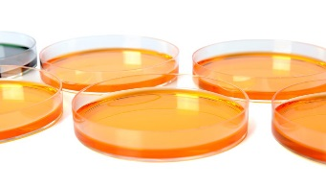
CFU stands for Colony Forming Units, a microbiology term used to quantify how many bacteria exist in a solution. Depending on the concentration of your sample, you need to perform multiple dilutions and plate the different samples onto petri dishes. If you have too many bacterial colonies, they are hard to count, and if there are too few, the sample may not be representative. It is generally a good idea to plate the original solution, then a 1/10 dilution (1 part solution, 9 parts saline), a 1/100 dilution and possibly a 1/1000 dilution.
Calculating CFU from Bacterial Dilution
Perform Preliminary Count
Perform a preliminary count of each dish once the bacteria incubates, which usually takes one or two days. Count only individual colonies, which should be distinct, isolated dots, not a whole blob of different colonies grown together. Choose the plate which has more than 30 of these colonies but less than 300.
Count Individual Colonies
Count the number of individual colonies. This is the CFU number of your dilution -- you will have to perform a simple calculation to determine the CFU of the original sample. For this example, use a hypothetical plate containing 46 colonies.
Determine Size of Dilution
Determine the size of the dilution you used. (Ideally, you labeled the petri dishes ahead of time.) For this example, mix 1 mL of bacterial culture with 99 mL of saline. This is a 1/100 dilution.
Multiply Degree of Dilution by Amount Plated
Multiply the degree of the dilution by the amount you actually plated. If you plated 0.1 mL of your 1/100 dilution onto the agar, you multiply 0.1 x 1/100, for a result of 1/1000 or 0.001.
Divide CFU of Dilution
Divide the CFU of the dilution (the number of colonies you counted) by the result from step 4. For this example, you work out 46 ÷ 1/1000, which is the same as 46 x 1,000. The result is 46,000 CFU in the original sample.

Testing antibiotic activity using the disk diffusion assay
You must watch this video:
https://www.google.com/search?q=how+to++test+for+antibiotic+using+filter+disks+on+lawn&gws_rd=ssl#gws_rd=ssl&kpvalbx=_0dpSXduyLaem_QaUjoVw7&spf=1565711057332

Outline for Lab Reports
An outline is a plan or blueprint for your report. It helps you structure your report by using roman numerals, letters and numbers to organize each section of the report. Use the outline below as a template to guide you by writing your information in each section. You need not limit yourself to this outline, therefore, you can use more letters and numbers if warranted. This outline will later be used to help you put together your lab report as you add more information to it. The final lab report will not include the roman numerals, letters and numbers but instead you will write each section in paragraph form.
Title and date (centered on first page)
The title should reflect the independent and dependent variable. For example, “The effects of Hypericum extract on the growth of Staph. epidermydis”. It should be brief and descriptive.
- Introduction
- Include (here) a few sentences of preliminary observations or background information (what is already known) about the subject
- Answer here: Why is the lab experiment being done (What do you hope to learn)?
- Hypothesis
- Include here a possible answer to why you are doing the lab (If we do this…. then we think this should happen)
- Identify independent and dependent variables here
- Materials and Methods
- For this section of the outline briefly state in step-by-step fashion what and how you did the experiment. Write down how lab was conducted with materials as part of the procedure.
- Include controls used here
- Results
- Here summarize data collected by describing a condensed version of the data
- Use tables, graphs, and charts with appropriate units, labeled axis and legends
- Discussion
- First, state whether you accept or reject your hypothesis based on your results.
- Then include interpretations and opinions of your data and observations
- Why did the results turn out the way they did?
- How does your control affect the results?
- Discuss any sources of error. Include any unusual circumstances, problems or difficulties that were encountered and ways they could be improved.
- In this section you should discuss how the information gathered during the project is useful to society or the individual and what you have learned.
References
Properly cite all sources used. Minimum of two major sources one of which includes the lab manual.
PLANTS FOR TEAMS TO RESEARCH FOR LABELS FALL 2019 (Design Team only)
PICK ONE OF THESE
- Poet’s laurel Danae racemosa
Maleki-Dizaji, Nasrin; Fathiazad, Fatemeh; Garjani, Alireza (2007-12-01). "Antinociceptive properties of extracts and two flavonoids isolated from leaves of Danae racemosa". Archives of Pharmacal Research. 30 (12): 1536–1542. ISSN 0253-6269. PMID 18254240
- Wild Quinine Parhenium integrifolium L https://plants.usda.gov/plantguide/pdf/cs_pain3.pdf
- Valeriana
https://nccih.nih.gov/health/valerian
- Paw-Paw
- Lucifer tongue
- St. John’s Wort
- Campotheca
https://medicinalplants101.blogspot.com/2014/01/camptotheca-aka-cancer-tree.html
- Staghorn sumac
http://eattheplanet.org/staghorn-sumac-tea/
- Macleaya Plume Poppy
- Hedera English Ivy https://pdfs.semanticscholar.org/0f38/cf404822fe200cb69c42a3a9dd067503369c.pdf

AND PICK ONE OF THESE
- Vinca
- Galega
- Capsicum
- Cannabis
- Digitalis Foxglove
- Atropa
- Papaver
- Colchicum autumnale
- Glory lily
- Salix nigra black willow

