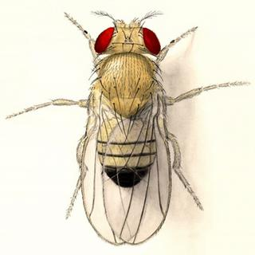

BIOL 443

Class Time:
Tues. & Thurs. 12:30-1:45 in GSB 1374

Instructor:
Daniel J. McKay, Ph.D.

Email:
dmckay1@email.unc.edu

Office Hours:
Thurs. 1:45-3:15
GSB 3358
(or by appointment)

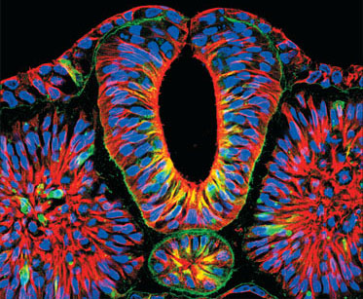
Developmental Biology

Course Description:
An experimental approach to understanding animal development. This class will cover developmental processes, molecular, genetic, cell biological, and biochemical techniques, with an emphasis on the molecules involved in development. It is assumed that students will have some familiarity with animal development. This course will focus deeply on selected developmental processes rather than taking a superficial approach to a broad number of developmental processes. To facilitate a deeper understanding of the scientific method, each topic will be paired with a research paper from the primary literature.

Expectations:
Students will be expected to do assigned readings before class!! Participation is a must in this course. You will be expected to contribute to class discussions on a daily basis, and you will be expected to work in groups.

Course Objectives:
Upon completion of the course, students will be able to…
- articulate the big questions being addressed in developmental biology, such as those related to gene regulation, epigenetics, cell fate specification, and patterning.
- read and interpret primary literature in developmental biology.
- understand the tools used by researchers to investigate the mechanisms underlying development.
- know the criteria for proof, and recognize good and bad experimental design.
- propose solutions to address unanswered questions in developmental biology.

Textbook
This course will use Gilbert’s “Developmental Biology”, 11th edition. I will also be providing reading assignments in the form of current articles and primary research papers, as well as information from other forms of media.

Schedule
August 20: Introduction to Developmental Biology.
August 22: Model organisms and genomic equivalence.
August 27: no class; special seminar, Carrington L300, Fox Auditorium.
August 29: Discussion of PAPER 1; Regulation of gene expression I.
September 3: Regulation of gene expression II.
September 5: Stem cells and developmental potency.
September 10: Discussion of PAPER 2.
September 12: Fertilization and sex determination I.
September 17: Discussion of PAPER 2, continued.
September 19: Fertilization and sex determination II.
September 24: EXAM 1.
September 26: Drosophila anterior-posterior patterning I.
October 1: Drosophila anterior-posterior patterning II.
October 3: Discussion of PAPER 3.
October 8: Discussion of PAPER 4.
October 10: Early vertebrate development.
October 15: Vertebrate gastrulation and neurulation.
October 17: no class, FALL BREAK.
October 22: Somitogenesis I.
October 24: Student Presentations: PAPER 5.
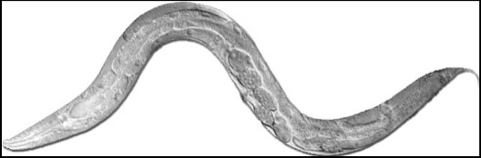

October 29: Student presentations: PAPER 6.
October 31: Somitogenesis II.
November 5: EXAM 2.
November 7: Tetrapod limb development I.
November 12: Tetrapod limb development II.
November 14: Student Presentations: PAPER 7.
November 19: Student Presentations: PAPER 8.
November 21: Nervous system development I.
November 26: Nervous system development II.
November 28: no class, THANKSGIVING BREAK.
December 3: Student Presentations: PAPER 9.
Friday December 5: FINAL EXAM, 12pm.

Please note the schedule is subject to change.

Course Policies

1. Exams
There will be two exams during the semester and one final exam. The final exam will be cumulative, with an emphasis on untested material.

2. Attendance
All registered students are expected to:
–be on time for all class periods.
–attend all classes (more than two unexcused absences will incur grade penalties).
–meet deadlines for homework and other assignments.

3. Participation
Participation during the class period is required. Every student should participate verbally in every class. This would include asking a question, commenting on other student’s comments (respectfully), responding when asked questions directly, and participating in small group work.
Students are expected to:
–be courteous and respectful to other participants and ideas.
–actively contribute in a substantial way to class discussions and small group work.
–honor the Honor Code.

4. Homework and Quizzes
Homework will be assigned in advance as much as possible; however, the flexible and dynamic nature of this class may make it difficult to do so far in advance.

5. Grading:
75% Exams
25% Participation, homework & class preparedness

Please note that I reserve the right to make changes to the syllabus, including project due dates and test dates (excluding the officially scheduled final examination), when unforeseen circumstances occur. These changes will be announced as early as possible so that students can adjust their schedules.

HONOR CODE: All work done in this class must be carried out within the letter and spirit of the UNC Honor Code. You must sign a pledge on all graded work certifying that no unauthorized assistance has been given or received. You are expected to maintain the confidentiality of examinations by divulging no information about any examination to a student who has not yet taken that exam. You are also responsible for consulting with your professors if you are unclear about the meaning of plagiarism or about whether any particular act on your part constitutes plagiarism. Please talk with the professor if you have any questions about how the Honor Code pertains to this course.

Course Copyright Information:
All course materials including your notes and assignments are covered by University Copyright Policy http://policies.unc.edu/files/2013/05/Copyright.pdf

Unauthorized sale, duplication, or posting is a violation of the Honor Code.

