LOCAL FLORA (BIOL 272, ENEC 272)

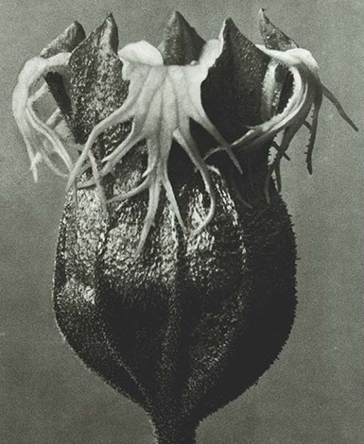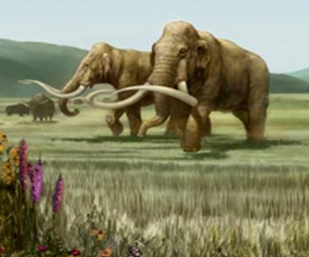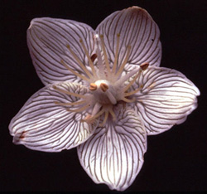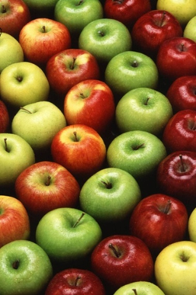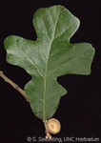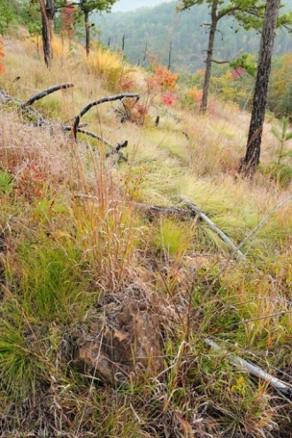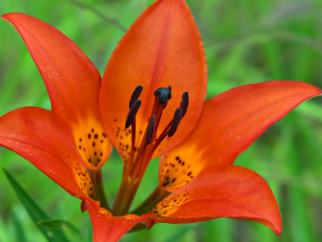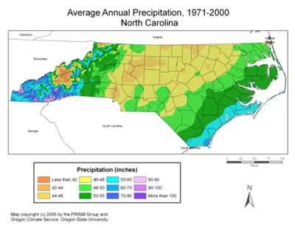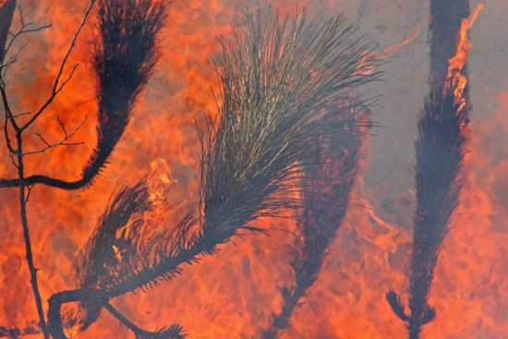

Instructor: Alan Weakley (email: weakley@unc.edu; office Coker Hall 419)
Teaching Assistants:
Joanna Spooner (email: jspooner@live.unc.edu; office Coker Hall 412)
Eric Ungberg (email: ungberg@gmail.com; office Coker Hall 412)
Credit Hours: 4
Office hours: By appointment.

Version
2019 Fall Semester.

Course Schedule -- Detailed schedule posted as spreadsheet
Lecture: MWF: 10:10-11:00 (Wilson 108)
Lab: M OR w: 1:25-4:15 (Wilson 140, or in the field)
Final Exam: 8-11 a.m., Friday, December 13th

Course Purposes
- Understand the diversity and evolution of plants
- Recognize native (and some alien) plants of North Carolina (especially the Piedmont), understand their ecology, economic importance, and conservation challenges
- Look at plants – learn to see and describe their details; learn plant structures needed to identify plants, and some specialized terminology that describes those structures
- Identify plants using books and online tools (a skill to last a lifetime); use “keys” and other identification tools to aid in the identification of plants
- Make “citizen science” observations of plants on campus and nearby, identifying plants, confirming the identifications of others, and adding to data on our local UNC and Triangle flora
- Learn about the biogeography, forest types, and plant diversity of North Carolina
- Appreciate conservation needs of the North Carolina flora
- Plants we eat and wear – what are they and where do they come from?

Course Texts
Judd et al. (2016) Plant Systematics: A Phylogenetic Approach (4th Edition)
Weakley, Ludwig, & Townsend (2017) Flora of Virginia app. Ca. $19.99 on iOS or android
Optional: Weakley, Ludwig, & Townsend (2013) Flora of Virginia – copies available for use in labs
Optional: Weakley (2015, 2019) Flora of the Southern and Mid-Atlantic States] – copies available for use in labs
Optional: Weakley & Lee (2017) FloraQuest (an iOS app) – available in the Apple Store]; Flora of Virginia App, available in any app store

Assignments and Grading
Lecture exams (45%): These are a mixture of short answer, long answer, multiple choice, matching.
Midterm 20%
Final 25% (cumulative, sort of)
Lab quizzes (30%):
4 quizzes on recognition and identification of 100-110 plant species (5%, 5%, 5%, 7%)
1 FloraQuest (“scavenger hunt”), working in teams to find examples of 75 plant features! (8%)
Citizen Science Project (20%): Make observations of native and naturalized plants in iNaturalist and identify and comment on others’ observations. Write a short reflection on the experience.
“Plants you ate and drank in a day” log (5%)

Course policies
Office hours and availability
The TA is the first option for meeting about any issues, but I am also available. I am usually available immediately following class to talk with you or to schedule appointments. For longer meetings, it’s usually best for us to schedule an appointment. Email is the best way to contact me to schedule appointments, ask questions, let me know about an absence, etc. I check email regularly during weekdays and early evenings, and I can usually respond to you within a few hours (often sooner). While I cannot guarantee a reply late at night or over the weekend, I am usually able to respond within 24 hours. If I know I will be unavailable by email on a particular weekend, I will notify the class in advance.

Participation and attendance
Attendance for all tests and quizzes is mandatory, and can only be made up if formally excused. Attendance in class and labs is strongly encouraged, but not mandatory; note, however, that non-attendance is strongly correlated with lower grades. Attendance and general involvement with the class is also used as a basis for any tweaking of your final grade.

Late work
This applies realistically only to the Project. 20% deduction per day.

Plagiarism

Carefully review UNC policies on plagiarism. This will mainly pertain to your individual project. We will carefully scrutinize these papers for signs of plagiarism, and will report plagiarism if found.
This course is designated as addressing the following two Focus Capacities:

Natural Scientific Investigation
Students learn how to make and interpret scientific descriptions and explanations of the natural world, practice the skills of scientific inquiry, and evaluate scientific evidence within the contexts of both scientific communities and society.
Questions for Students
- What rules govern the natural world and how are they discovered, tested, and validated?
- What is distinctive about the approach to understanding employed in the natural sciences?
- What challenges are encountered in making measurements of the natural world?
- What are the limits of investigation in the natural sciences?
Learning Outcomes
- Demonstrate the ability to use scientific knowledge, logic, and imagination to construct and justify scientific claims about phenomena, including validation through rigorous empirical testing.
- Analyze and apply processes of natural scientific inquiry as dictated by the phenomena and questions at hand. These include generating and testing hypotheses or theories; using logic and creativity to design investigations to test these hypotheses; collecting and interpreting data; making inferences that respect measurement error; building and justifying arguments and explanations; communicating and defending conclusions; revising arguments and conclusions based on new evidence and/or feedback from peers; and synthesizing new knowledge into broader scientific understanding.
- Evaluate science-related claims and information from popular and/or peer-reviewed sources by examining the relationship between the evidence, arguments, and conclusions presented and by assessing consistency with existing knowledge from valid and reliable scientific sources.
- Identify, assess, and make informed decisions about ethical issues at the intersections of the sciences and society.
Recurring Capacities
Focus capacity classes sustain the recurring capacities of inquiry that guide the general education mission. As appropriate to the course’s topic, each class should:
- Pose problems and questions that require systematic thinking about evidence, argument and uncertainty;
- Consider its content in the context of human difference between and within societies; the full range of legitimate debate in its field; and/or change over time
- Require
  - Writing totaling at least 10 pages in length, or the intellectual equivalent.
  - Presenting material to the class, small groups, or the public through oral presentations, webpages, or other means that enable corroboration of fact and argument.
  - Collaborating in pairs or groups to learn, design, solve, create, build, research or similar.

2. Empirical Investigation Lab
One Focus Capacity course must include or be associated with a one-credit Empirical Investigation Lab. In such labs, students participate in measurement, data collection and analysis, and hypothesis testing connected to the course content. An Empirical Investigation Lab is not usually a separate class; ordinarily it is a fourth credit attached to another Focus Capacity class.
- Take empirical measurements using appropriate apparatus.
- Generate and test hypotheses.
- Gather, store, and organize data.
- Analyze and report on data and hypothesis testing.

